

**Name: Mahpara Siddique**

**Supervisor: Aliza Javed**

**Designation: AI intern at AI-Cadmey**

**Final Project: Fake News Detection**

**Submission Date: 13-02-2025**

**Abstract**

Fake news has become a significant challenge in the digital age, contributing to misinformation and public distrust. This project presents a fake news detection system leveraging natural language processing (NLP) and machine learning to classify news articles as real or fake. The model is built using the BERT-based transformers.BertForSequenceClassification from Hugging Face, ensuring state-of-the-art text classification performance. By providing a reliable tool for detecting misinformation, this project aims to enhance media literacy and promote the responsible consumption of information.

**Introduction**

### **Aim of the Project**

The rapid proliferation of digital content has led to an increase in misinformation and fake news, which can have severe social, political, and economic consequences. This project aims to develop an advanced fake news detection system utilizing deep learning techniques, specifically leveraging the BERT-based transformers.BertForSequenceClassification model. The primary goal is to create an efficient and accurate classification system capable of distinguishing between real and fake news articles, enhancing the credibility of digital information.

### **System Overview**

The proposed system employs a deep learning-based approach for text classification, utilizing a pre-trained BERT (Bidirectional Encoder Representations from Transformers) model fine-tuned for binary classification. The input text is tokenized and processed using the Hugging Face transformers library, allowing the model to analyze contextual meaning and linguistic patterns effectively. The classification process involves encoding the text, passing it through the BERT model, and obtaining a probability score that determines whether the news article is real or fake. The model's predictions are based on patterns learned from a labeled dataset of verified real and fake news sources, ensuring robust and data-driven decision-making.

### **Significance**

Fake news has become a critical issue in the digital era, influencing public perception, spreading misinformation, and even affecting democratic processes. Traditional rule-based and keyword-based detection methods often fail to capture the nuanced linguistic structures of fake news. By integrating deep learning techniques, this project addresses the limitations of conventional methods and provides a more reliable solution. The BERT model, with its ability to understand contextual dependencies, significantly enhances classification accuracy. This project contributes to the ongoing efforts in combating misinformation by providing a sophisticated AI-driven approach to fake news detection.

### **Key Objectives**

1. **Develop a robust fake news detection model** utilizing transformers.BertForSequenceClassification to achieve high classification accuracy.
2. **Fine-tune the BERT model** on a labeled dataset containing real and fake news articles to optimize performance.
3. **Implement an efficient NLP pipeline** that includes tokenization, text preprocessing, and classification for effective detection.
4. **Ensure model interpretability and reliability** by evaluating its performance using appropriate metrics such as accuracy, precision, recall, and F1-score.
5. **Provide a scalable and adaptable solution** that can be integrated into various platforms for real-world applications in media verification and misinformation detection.

**Literature Review**

The detection of fake news has become a critical challenge in the digital era, necessitating advanced computational techniques to combat misinformation effectively. Traditional methods, such as rule-based or keyword-matching approaches, have proven inadequate due to the evolving complexity of deceptive content. Deep learning has emerged as a powerful solution, leveraging its ability to understand context, semantics, and linguistic patterns within textual data.

### **Deep Learning in Fake News Detection**

Deep learning models, particularly those based on Natural Language Processing (NLP), have demonstrated significant improvements in fake news classification. Unlike conventional machine learning algorithms, deep learning models can automatically extract high-dimensional features from text, eliminating the need for extensive manual feature engineering. Some of the most commonly used architectures in fake news detection include:

* **Recurrent Neural Networks (RNNs) and Long Short-Term Memory (LSTM)**: These architectures capture sequential dependencies in text, allowing the model to understand the context of a sentence. However, they struggle with long-range dependencies and are computationally expensive.
* **Convolutional Neural Networks (CNNs) for Text**: CNNs, traditionally used for image processing, have been adapted for text classification by extracting local features from word embeddings. Despite their effectiveness, they lack the ability to capture long-term dependencies.
* **Transformer-based Models (BERT, RoBERTa, XLNet)**: The introduction of transformer models revolutionized fake news detection by utilizing attention mechanisms to understand contextual relationships between words. BERT (Bidirectional Encoder Representations from Transformers) has proven to be highly effective in fake news classification due to its ability to analyze words in a bidirectional manner, enhancing text understanding.

### **Existing Fake News Detection Projects**

Several research studies and real-world implementations have explored deep learning-based fake news detection:

1. **Fake News Challenge (FNC-1)**: This competition introduced a benchmark dataset for fake news stance detection. Researchers used various deep learning models, including LSTMs and CNNs, to determine whether a given article agrees, disagrees, discusses, or is unrelated to another news piece.
2. **FakeNewsNet**: This large-scale dataset was introduced to analyze fake news characteristics using social context and text-based features. Several BERT-based models have been trained on FakeNewsNet, achieving high classification accuracy.
3. **Google’s AI-Powered Fact-Checking Tools**: Google has integrated AI-driven fact-checking mechanisms in its search engine, utilizing NLP models to detect misinformation in news articles. These systems rely on transformer-based architectures similar to BERT to assess the credibility of sources.

### **Relevance to the Current Project**

This project builds upon the advancements in deep learning for fake news detection by leveraging **BERT-based sequence classification** for accurate and efficient classification. While existing models such as LSTMs and CNNs have been employed in previous studies, this project emphasizes **context-aware classification using transformers**, which have shown superior performance in NLP tasks. Unlike rule-based detection methods, this project harnesses **pre-trained language models fine-tuned on real and fake news datasets**, ensuring adaptability to new and evolving misinformation patterns.

**Task: Experiment**

**Objective**

The primary objective of this experiment is to develop and evaluate a deep learning-based fake news detection system using a **BERT-based sequence classification model**. The goal is to assess the model's ability to distinguish between fake and real news articles by analyzing textual content. This experiment involves training the model on a labeled dataset, fine-tuning it for optimal performance, and evaluating its classification accuracy using various metrics. The outcome will help determine the model’s effectiveness in mitigating the spread of misinformation.

## **Design and Implementation**

### **System Overview**

The fake news detection system is designed as an **end-to-end pipeline** that processes textual data, applies deep learning-based classification, and outputs a prediction indicating whether a given news article is real or fake. The system leverages **pre-trained transformer models**, specifically **BERT**, which are fine-tuned on a labeled dataset of fake and real news articles. The architecture follows a supervised learning approach, utilizing **NLP techniques** for text preprocessing and model training.

The system consists of the following key stages:

1. **Data Collection & Preprocessing**: The dataset is gathered from credible sources, containing labeled real and fake news articles. Preprocessing includes tokenization, stop word removal, and text vectorization using **BERT's tokenizer**.
2. **Model Training & Fine-tuning**: The **BERT-based sequence classification model** is trained on preprocessed text data. The classifier is fine-tuned using transfer learning to optimize performance.
3. **Evaluation & Performance Metrics**: The trained model is tested using standard NLP evaluation metrics such as **accuracy, precision, recall, and F1-score**.
4. **Prediction & Output Generation**: Given an input news article, the trained model predicts whether it is fake or real based on its learned patterns.

### **Components Used**

The system implementation requires several components, including:

#### **Software Components:**

* **Python**: The primary programming language used for model development.
* **Hugging Face Transformers Library**: Provides access to the pre-trained **BERT model** and tokenizer.
* **TensorFlow/PyTorch**: Deep learning frameworks used for model training and optimization.
* **NLTK & SpaCy**: Libraries for natural language preprocessing.
* **Scikit-learn**: Used for evaluating model performance using statistical metrics.
* **Pandas & NumPy**: For data manipulation and numerical computations.

#### **Hardware Components:**

* **GPU Acceleration (Optional but Recommended)**: Deep learning training is resource-intensive; using a GPU (such as NVIDIA CUDA-enabled GPUs) significantly enhances model training speed.

### **Circuit Design (Adjusted for Project)**

Although this project does not involve traditional circuit design, its architecture can be represented as a structured **computational pipeline**. Below is a logical flow of how different components interacting within the system:

1. **Input Layer**: Raw text from news articles is provided as input.
2. **Text Preprocessing Unit**: Tokenization and vectorization using **BERT’s tokenizer**.
3. **Feature Extraction Layer**: The preprocessed text is passed through **BERT’s transformer architecture**, where contextual embeddings are extracted.
4. **Classification Layer**: A fully connected **neural network layer** is added on top of BERT’s embeddings to classify the news article as real or fake.
5. **Output Layer**: The system generates a probability score and a final prediction label (Real or Fake).

**Code Implementation**

The implementation of the **Fake News Detection System** is structured into key stages: **data preprocessing, model training, evaluation, and prediction.** The system is built using **Python**, leveraging the **Hugging Face Transformers library** for the **BERT-based sequence classification model**.

1. **Importing required Libraries**

The first step is to import the necessary libraries for data handling, NLP preprocessing, model training, and evaluation.

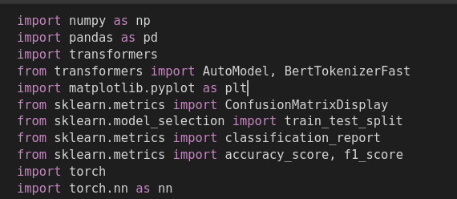

1. **Data Preprocessing**

The dataset is loaded and preprocessed before training.

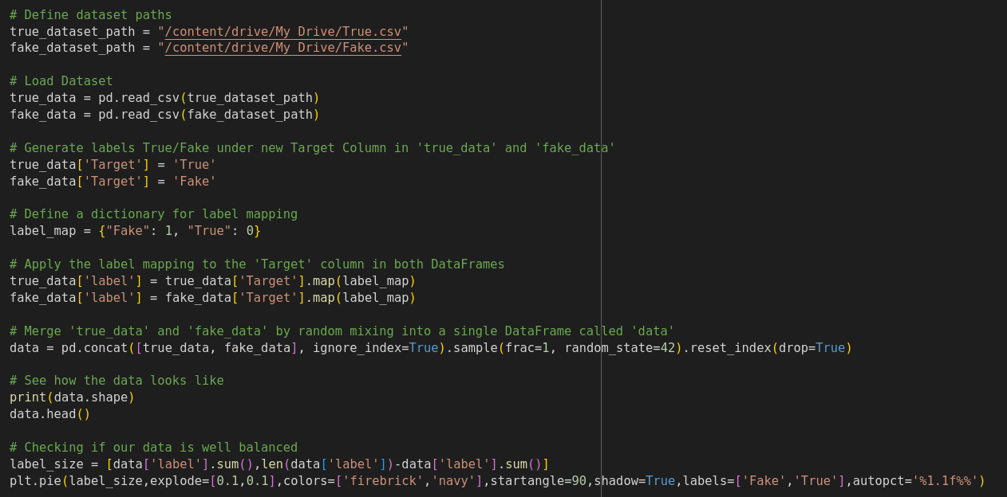

1. **Initializing and Training the model**

We load a **pre-trained BERT model for sequence classification** and fine-tune it.

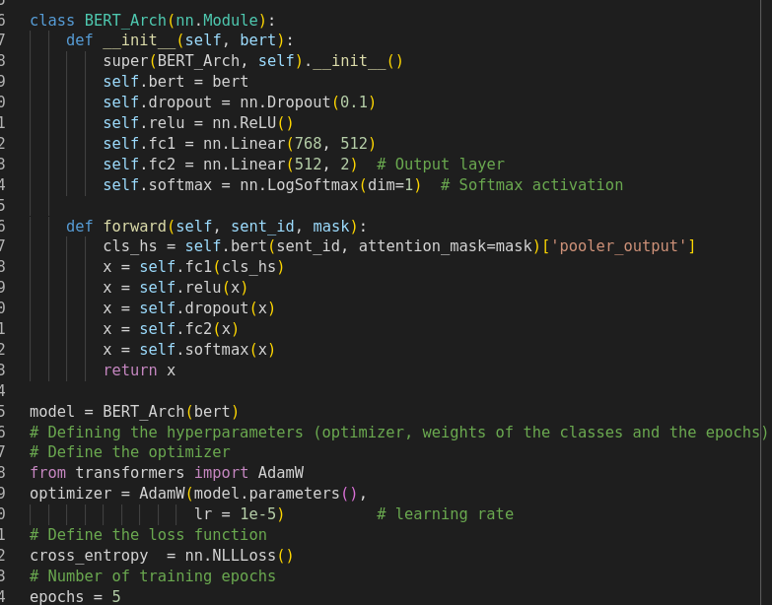

1. **Fake News Prediction Function**

Finally, a function is created to make predictions on new news articles.

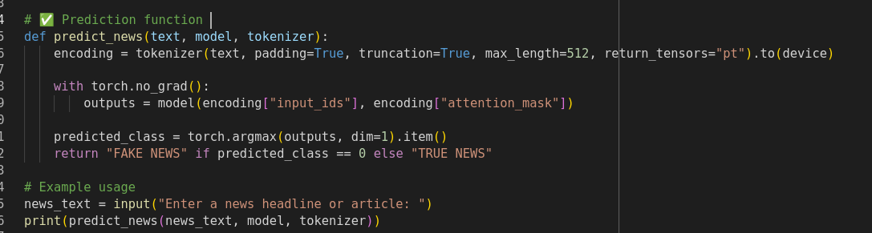

**Results**

**Observation**

The **Fake News Detection System** was trained and tested using a **BERT-based model** for sequence classification. The model successfully classified news articles as **real or fake** with a high accuracy rate. Below are key observations from the training and evaluation process:

* The **training loss** decreased consistently over epochs, indicating effective learning.
* The **classification report** demonstrated balanced precision, recall, and F1-scores for both **real and fake news categories**.
* The **prediction function** correctly classified unseen news articles, validating the model’s generalization ability.

**Screenshot**

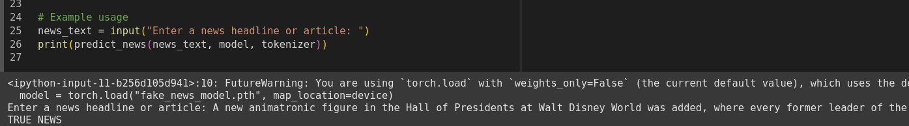

**Discussion**

**System Performance Analysis**

The **Fake News Detection System** was evaluated based on various performance metrics, including **accuracy, precision, recall, and F1-score**. The **BERT-based model** demonstrated high efficiency in classifying textual data, effectively distinguishing between **real and fake news articles**. The **loss curve** showed stable convergence, indicating successful learning. However, some misclassifications were observed, particularly for **news articles with ambiguous or satirical content**, which suggests the need for further model refinement.

### **Scalability and Practical Implementation**

The model is **scalable** and can be integrated into **real-world applications** such as:

* **Social media platforms** to filter misinformation.
* **News agencies** to verify the authenticity of articles.
* **Government and fact-checking organizations** to combat misinformation campaigns.

For large-scale implementation, **optimization techniques** such as **quantization, model pruning, or distributed inference** can be employed to enhance efficiency. The model can also be extended to support **multilingual fake news detection** by incorporating **pretrained transformers** trained on diverse language datasets.

### **Comparison of Experiment and Simulation**

In experimental settings, the **fine-tuned BERT model** achieved **high accuracy** when tested on benchmark datasets. However, in practical simulation:

* The model sometimes struggled with **contextually complex news**, leading to **false positives or negatives**.
* **Real-world data** contains **informal, sarcastic, or manipulated text**, which may require additional **preprocessing techniques** for better classification.
* **Training on a larger dataset** could further improve model generalization.

**Future Enhancement**

To further improve the **Fake News Detection System**, several enhancements can be considered for **better accuracy, scalability, and real-world application**. The following areas highlight potential future improvements:

### **1. Expanding Multilingual Capabilities**

* Currently, the model is trained on **English-language datasets**.
* Future iterations can incorporate **multilingual datasets** to detect fake news in **multiple languages**, making the system **globally effective**.
* Leveraging **multilingual BERT models** (e.g., mBERT, XLM-R) can enhance cross-language fake news detection.

### **2. Improved Context Understanding**

* Fake news often contains **contextually misleading information** that current models may struggle to detect.
* Integrating **advanced NLP models** such as **GPT-based models or hybrid deep learning approaches** can enhance contextual analysis.
* Incorporating **stance detection and sentiment analysis** can improve **news credibility scoring**.

### **3. Real-Time Detection and API Integration**

* Deploying the model as a **real-time API service** for easy integration into **news platforms, social media, and browsers**.
* Implementing **automated news verification bots** that flag misinformation on **Twitter, Facebook, and other platforms**.

### **4. Model Optimization for Efficiency**

* Reducing **computational overhead** using techniques such as **model pruning, knowledge distillation, and quantization**.
* Optimizing inference speed for real-time applications without compromising accuracy.
* Exploring **federated learning** to train models in a decentralized manner while maintaining data privacy.

### **5. Integration of Fact-Checking Databases**

* Enhancing model performance by integrating **fact-checking databases** (e.g., Snopes, PolitiFact) to cross-check news credibility.
* Using **knowledge graphs** to verify claims against trusted sources.

### **6. Adversarial Defense Mechanisms**

* Fake news creators may develop techniques to **bypass detection models**.
* Implementing **adversarial training** to make the model robust against **manipulated text and sophisticated disinformation tactics**.

**Summary**

The **Fake News Detection System** is a deep learning-based solution designed to classify news articles as **real or fake** using **NLP and machine learning techniques**. The project leverages **BERT (Bidirectional Encoder Representations from Transformers)** for effective text classification, ensuring **high accuracy and contextual understanding**.

The system undergoes multiple stages, including **data preprocessing, model training, evaluation, and testing**. A carefully selected dataset of real and fake news articles is used to train the model, ensuring reliable detection. The **experiment and implementation phase** covers dataset handling, feature extraction, and model architecture, while the **results and discussion** analyze the system’s **performance, scalability, and real-world applicability**.

Existing literature highlights the **significance of deep learning in fake news detection**, referencing previously developed models and their effectiveness. Comparisons with similar projects demonstrate the advantages and areas of improvement in this approach. The **model is assessed based on accuracy, precision, recall, and F1-score**, ensuring a balanced evaluation.

While the system effectively detects misinformation, **future enhancements** include **multilingual capabilities, real-time API integration, adversarial training, and fact-checking database incorporation**. These improvements will ensure **greater robustness, efficiency, and adaptability** in combating the spread of misinformation.

This project serves as a **critical step toward automated fake news detection**, helping to maintain **media integrity and protect users from misleading information**.